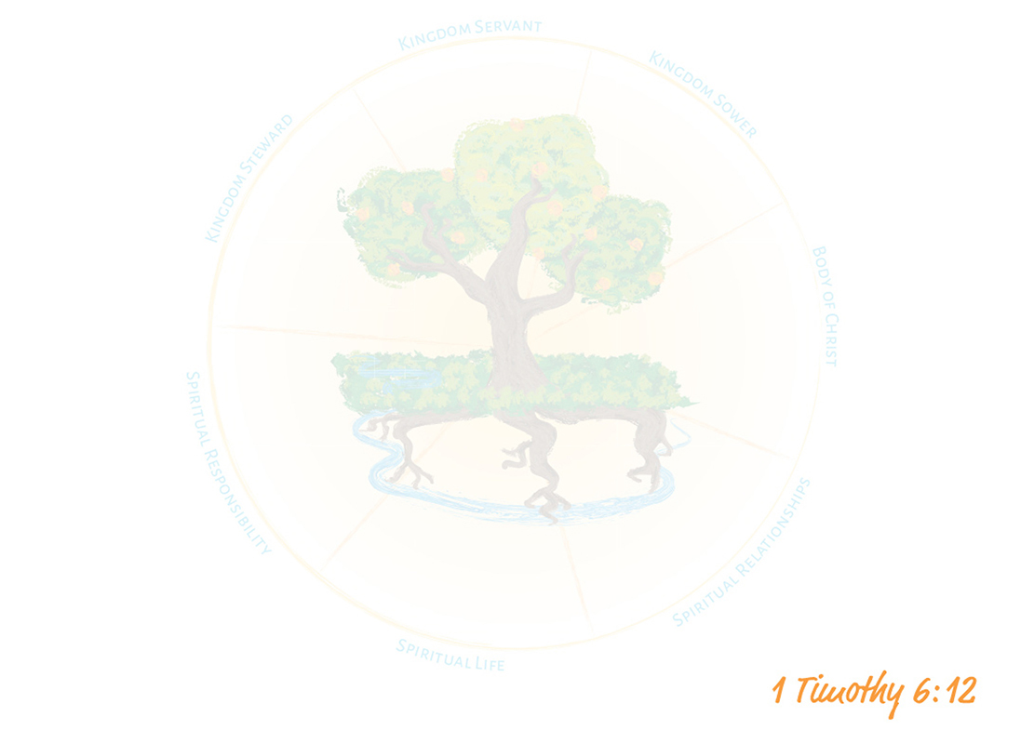
1MY KINGDOM LIFE PLAN
My Personal Mission Statement:

Spiritual RESPONSIBILITY | Spiritual Life | Spiritual Relationships | The Body | Kingdom Sower | Kingdom Servant | Kingdom Steward (Resources)
Daily
Weekly
Monthly
Quarterly
Biannually
Annually

